Distinguish the types of fraud in distinct companies:

*Banks:*

* Application and identity fraud
* Electronic fraud – e-mail scams
* Account takeover fraud
* Check Fraud
  + Depositing check info into account without proper authorization
  + Altering a check by changing info on it
  + Etc.
* Credit card Fraud

*Investment banking:*

* Affinity Fraud
* Advance Fee Fraud
* Binary Options Fraud
* High Yield Investment programs
* Internet and Social Media Fraud
* Microcap Fraud
* Ponzi Scheme
* Pyramid Schemes
* “Prime Bank” Investements
* Pre-IPO investment scams
* Promissory Notes
* Pump and Dump Schemes
* Commodity Pool Fraud
* Foreign Currency Trading Fraud

*Mortgage Fraud:*

* Air loans
* Appraisal fraud
* Soule-sales
* Straw buying

**Important feature of frauds**: they are quick to adapt, defense strategies must not be based on a single case. Both supervised and unsupervised AI models must be integrated in a cohesive strategy.

**Supervised learning:** Each transaction is tagged as fraud or non-fraud transaction. The amount of clean data is directly correlated with accuracy. Small perturbation of available data can augment the data set, improving the precision of the model. The proportion of non-fraudulent transactions vs fraudulent ones is very small, i.e. data is unevenly distributed. How to deal with this? Fraud tends to repeat, especially successful fraudulent techniques. Therefore it is important to distinguish previously seen fraudulent patterns.

**Unsupervised learning:** For spotting anomalous behavior, where there is no tagged transaction for those cases. This one detects outlier transaction and behavior that represent previously unseen forms of fraud.

Learning will be held as reinforcement learning and adaptive learning, where it will be tuned in case of false negatives/positives.

**Behavioral analytics:** understanding the behavior of profiles: individual, merchant, account. Profiles are updated with each transaction in real time.

Behavior types:

Monetary

* Spend velocity
* Hours and days to transact
* Time period between geographically disperse payments

Nonmonetary

* Change of address
* Password reset
* Request for a duplicate card

A **graph** analysis of cards could help to prevent false positives. In given time window (say 15 min) establish a relationship between cardholders, therefore if this cards have been used in this time window, it establishes a relationship. This information decreases chances of fraud.

First analyze generalized data and then, in case of fraudulent transaction, detect in a specialized manner if the transaction is fraudulent or not (avoiding false positives). Maybe the use of statistics and specialized data would help us to avoid false negatives.

Identify in what zones the cardholder moves, where the geographical zones are also clustered and labeled. For example, I would never go to San Felipe de Jesus, although my card was successfully used there. Also relate IP addresses where card is used, and the way it is used. For example, in my case, I had a card stolen, and the robbers went to Walmart. They used it several times until the limit of available money was used. Detect this kind of behavior.

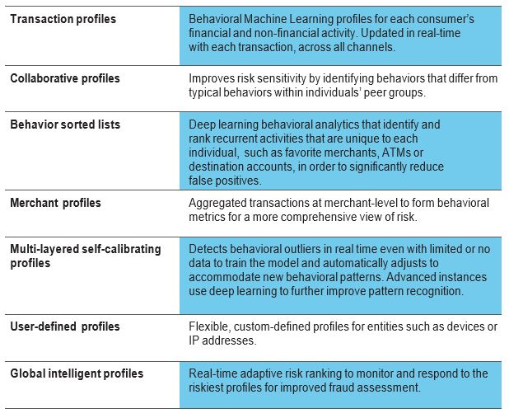

**Autoencoders** are also an important tool for fraud detection.

Datasets

<https://www.kaggle.com/akashkr/fraud-transaction>

<https://www.kaggle.com/mlg-ulb/creditcardfraud>

<https://www.kaggle.com/ntnu-testimon/paysim1>

References

1. <https://www.investor.gov/protect-your-investments/fraud/types-fraud>
2. <https://www.fico.com/blogs/analytics-optimization/5-keys-to-using-ai-and-machine-learning-in-fraud-detection/>
3. <https://www.fico.com/en/resource-download-file/6621>
4. <https://www.fico.com/en/resource-download-file/6596>
5. <https://www.fico.com/en/resource-download-file/6336>
6. <https://nethone.com/blog/beginners-guide-to-machine-learning/>
7. <http://www.datascienceblog.pw/introduction-to-fraud-detection-systems.html>
8. <https://medium.com/@curiousily/credit-card-fraud-detection-using-autoencoders-in-keras-tensorflow-for-hackers-part-vii-20e0c85301bd>